Day 1 – Software Testing Fundamentals & Login Testing
Name: Tehzeeb Masood
Role: Manual QA Engineer (Learning Portfolio)
Date: 22 July 2026

Topics Covered

Theory
- What is Software Testing?
- Why Software Testing is Important
- Bug vs Defect vs Failure
- Functional Testing
- Non-Functional Testing
- Unit Testing
- System Testing
- User Acceptance Testing (UAT)
- Severity vs Priority
- SDLC
- STLC
- SDLC vs STLC

SDLC Phases
- Requirement Gathering
- Planning
- Design
- Development
- Testing
- Deployment
- Maintenance

STLC Phases
- Requirement Analysis
- Test Planning
- Test Case Development
- Test Environment Setup
- Test Execution
- Test Closure

Difference Between SDLC and STLC
SDLC | STLC
Software Development Life Cycle | Software Testing Life Cycle
Used to develop software | Used to test software
Followed by Developers, QA, Designers, Business Analysts, etc. | Mainly followed by QA/Testers
Starts from requirements | Starts after QA receives requirements
Ends with maintenance | Ends with test closure
Goal: Build software | Goal: Ensure software quality

Practical Project

Project Name
Manual Testing of Login Functionality

Website
https://the-internet.herokuapp.com

Module Tested
Form Authentication (Login)

Test Cases Executed
ID | Test Case | Expected Result | Status
TC-001 | Valid Username + Valid Password | Login Successful | Pass
TC-002 | Invalid Username | Error Message | Pass
TC-003 | Invalid Password | Error Message | Pass
TC-004 | Logout | User Logged Out Successfully | Pass
TC-005 | Username with Leading Space | Login Failed | Pass
TC-006 | Username with Trailing Space | Login Failed | Pass
TC-007 | Password with Leading Space | Login Failed | Pass
TC-008 | Password with Trailing Space | Login Failed | Pass
TC-009 | Press Enter Instead of Login Button | Login Successful | Pass

Valid Login

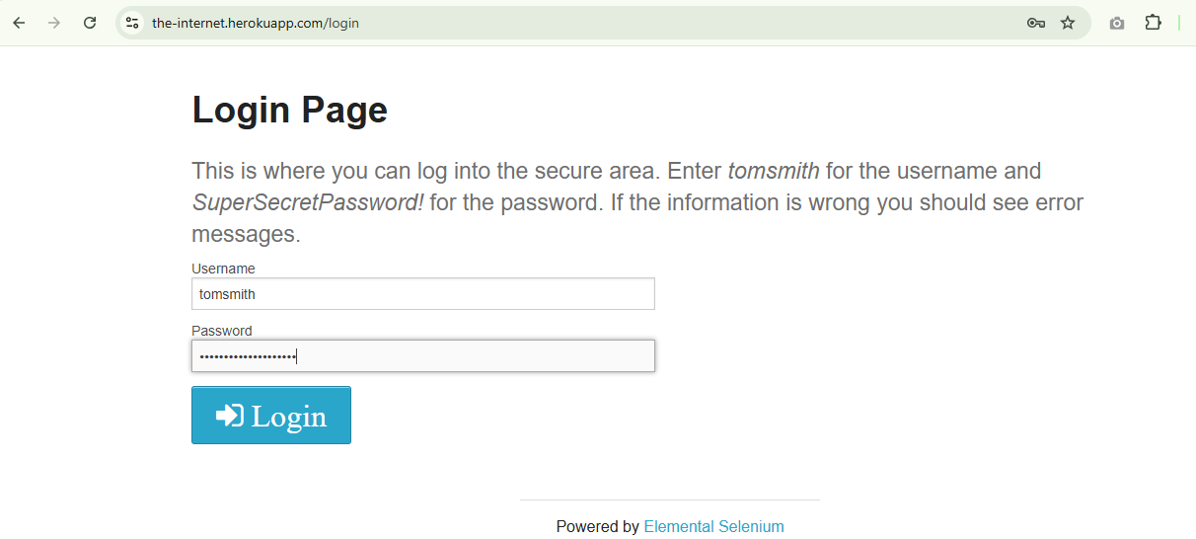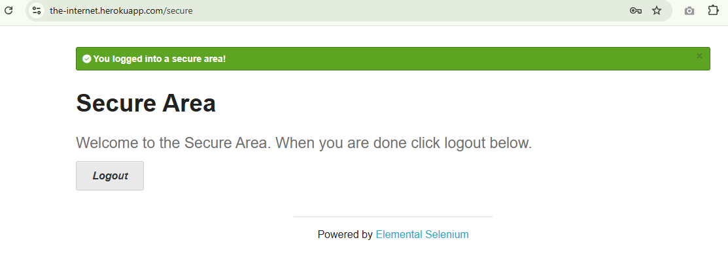
Invalid Username
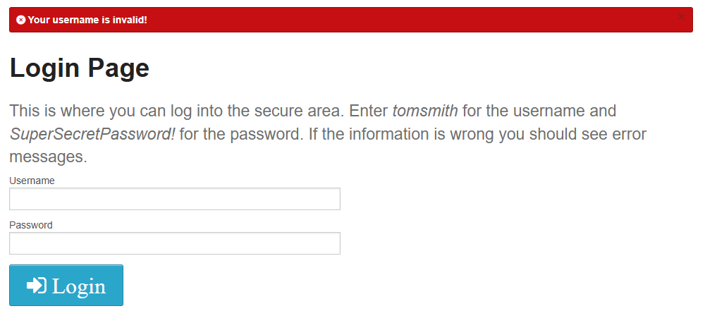
Invalid Password
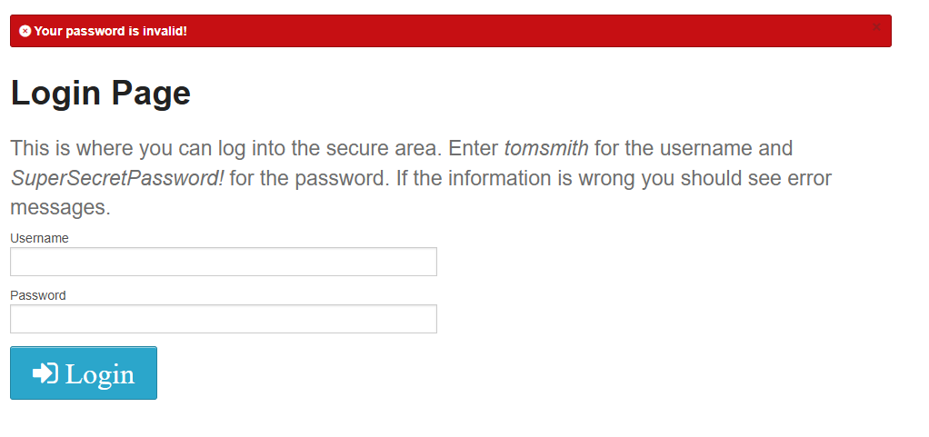
Logout
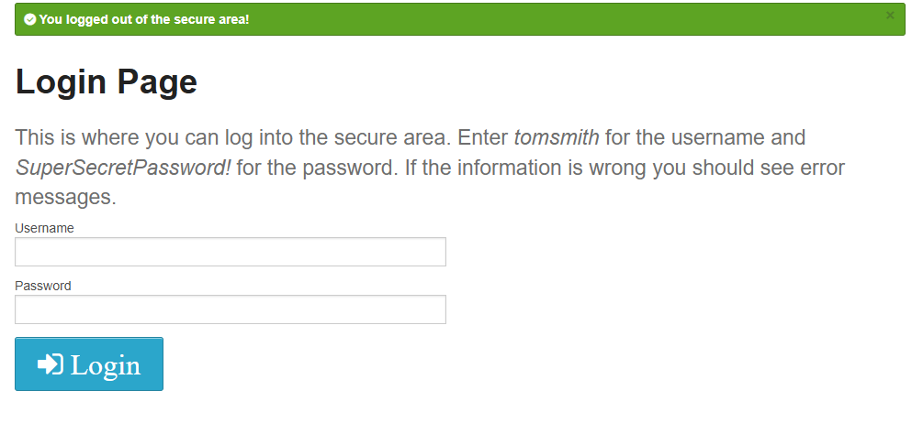
Username with Leading Space
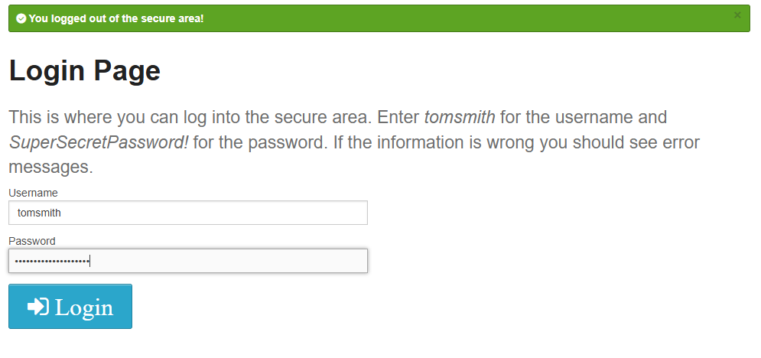

Username with Trailing Space

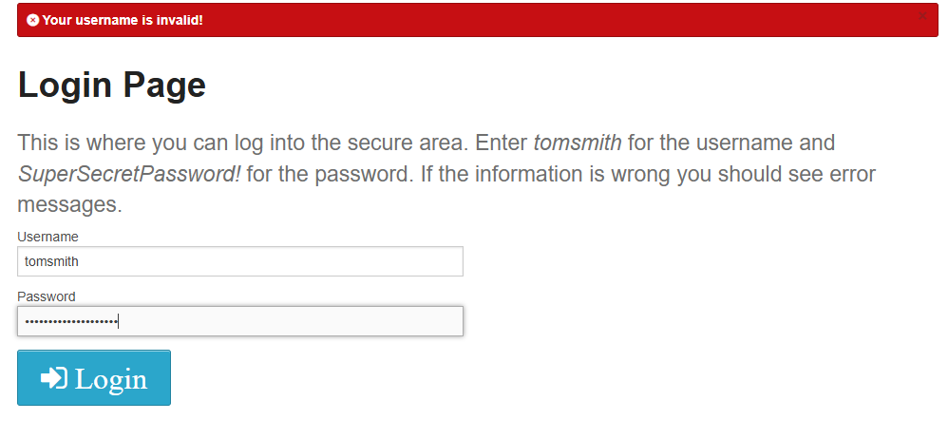

Password with Leading Space
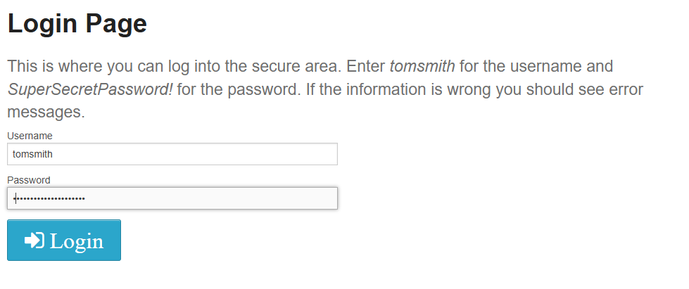

Password with Trailing Space

Press Enter Instead of Login Button


Additional Test Ideas
- Username and password are the same
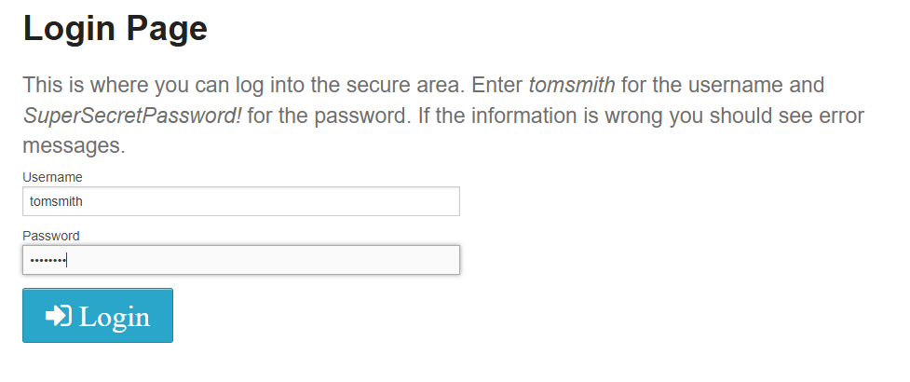

- Password with 500 characters
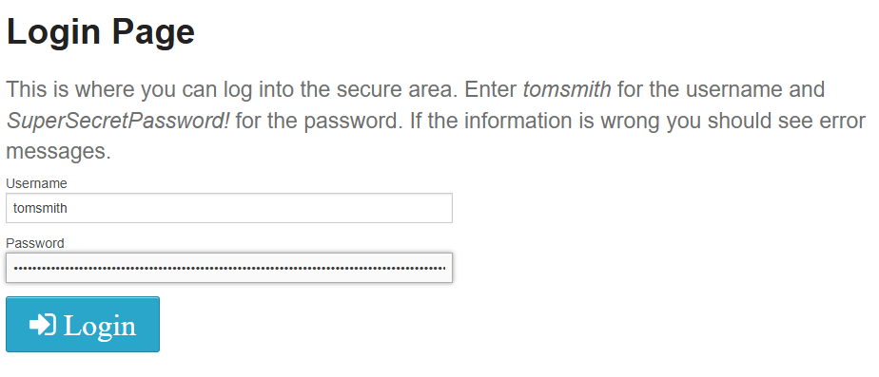

- Password as "password"

- Empty Username

- Empty Password

- Both fields empty

- SQL Injection Input
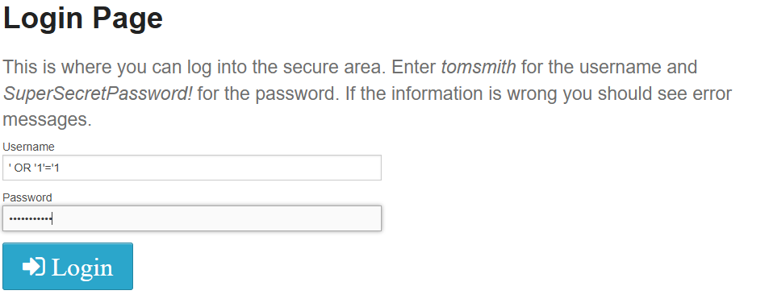

- HTML Input
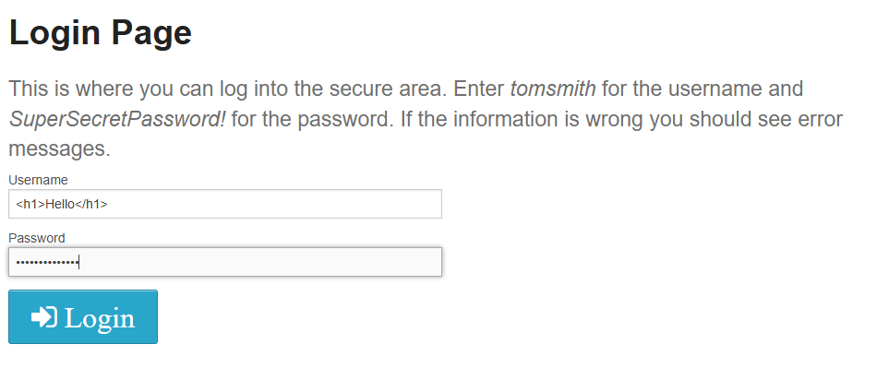

- JavaScript Input
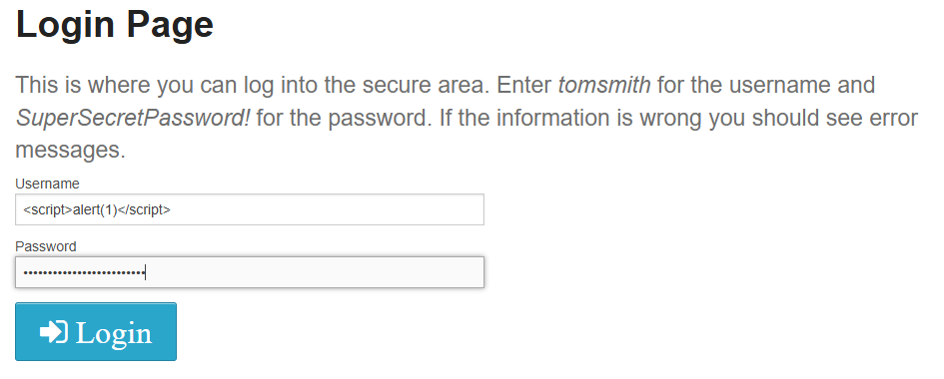

- Emoji Input
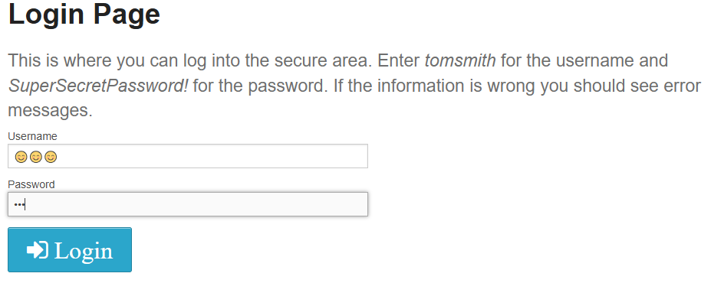


Concepts Applied
- Functional Testing
- Negative Testing
- Input Validation
- Edge Case Testing
- Boundary Value Thinking
- Usability Testing

Interview Questions Practiced
- What is Software Testing?
- What is a Bug?
- What is a Defect?
- What is a Failure?
- Functional vs Non-Functional Testing
- Unit Testing
- System Testing
- UAT
- Severity vs Priority
- SDLC vs STLC
- Can STLC start before SDLC?
- Who writes Test Cases?

Learnings
Today I learned the fundamentals of Software Testing and understood the difference between Bug, Defect, and Failure. I also learned Functional and Non-Functional Testing, SDLC, STLC, Severity, and Priority. Finally, I performed my first real-world manual testing on a live login page by executing multiple positive and negative test scenarios.

Skills Gained
- Software Testing Fundamentals
- Manual Testing
- Login Testing
- Test Scenario Thinking
- Expected vs Actual Result
- QA Mindset
- Basic Edge Case Analysis

Day 1 Status
Completed Successfully
-------------------------------------------------------

